Feedback System

- Student
- Teachers
- Employers
- Alumni

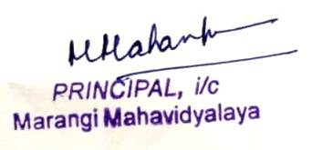

Feedback Analysis for Session 2023-24
Feedback From Teachers
https://docs.google.com/forms/d/e/1FAIpQLSe4cLVg5k6GfZkn113mkhS-e8bhjqF9kR6j1_ZsM7ATxP95ZA/viewform?usp=sharing

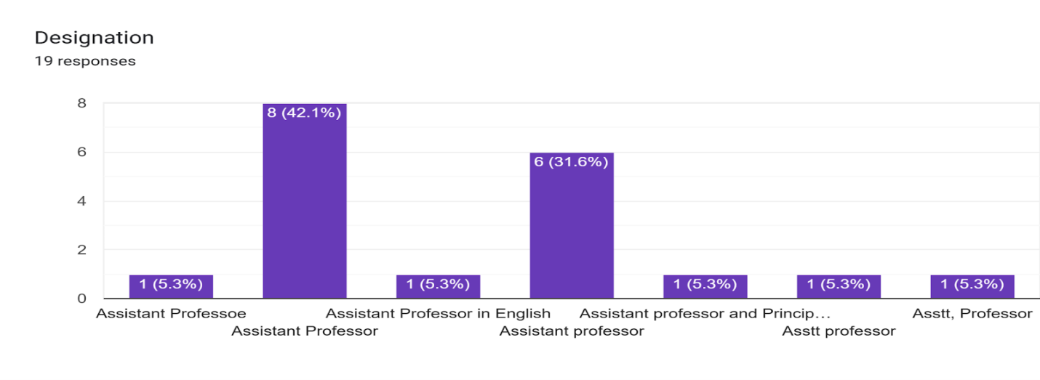
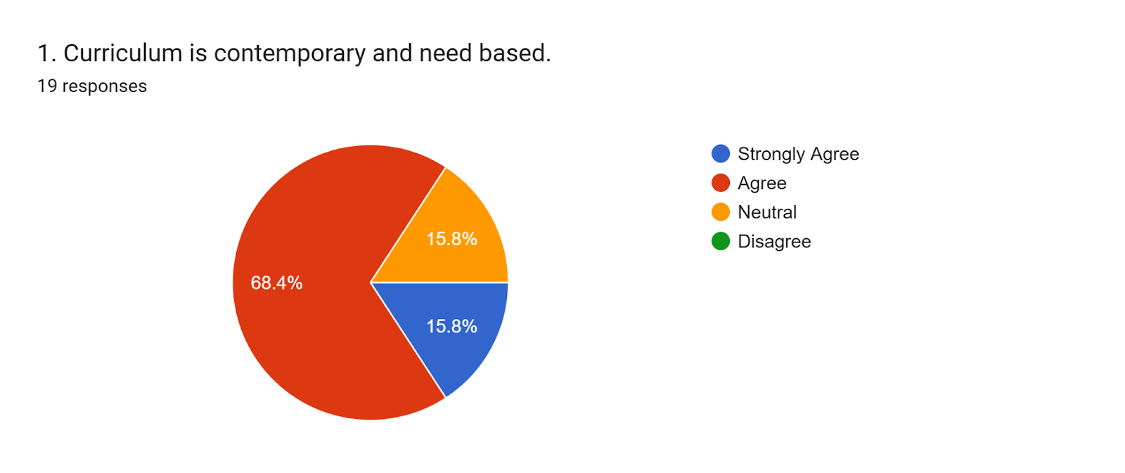

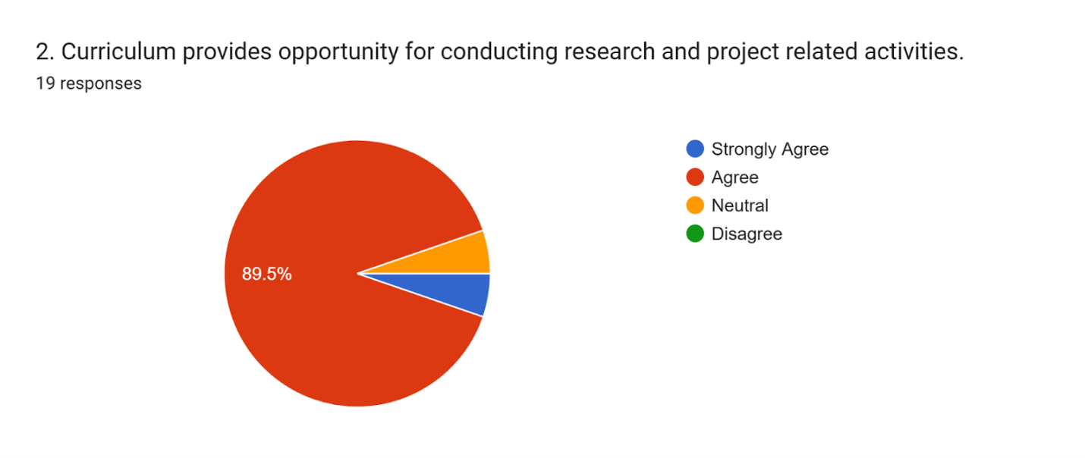
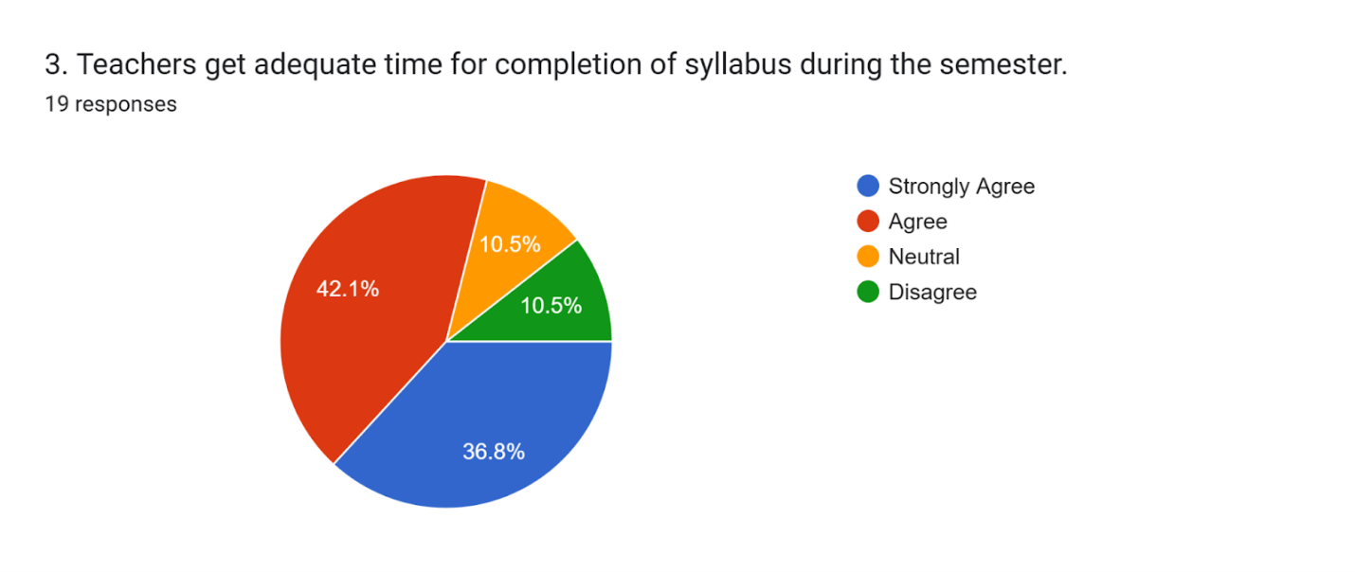

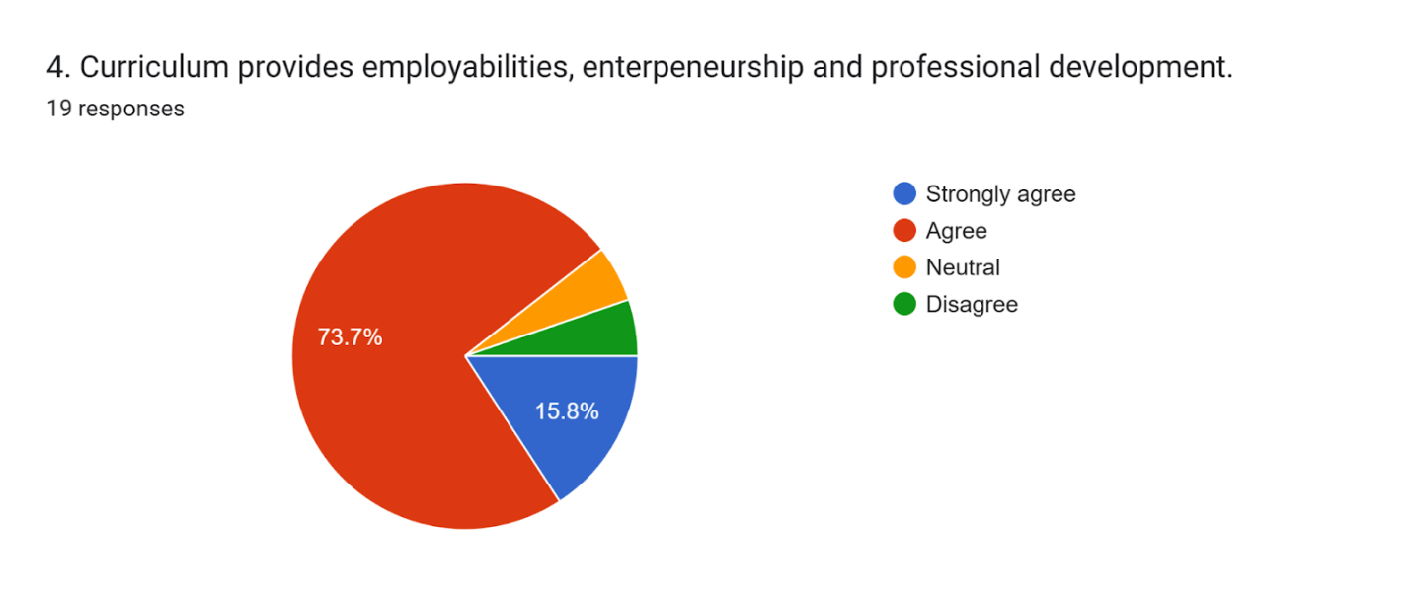

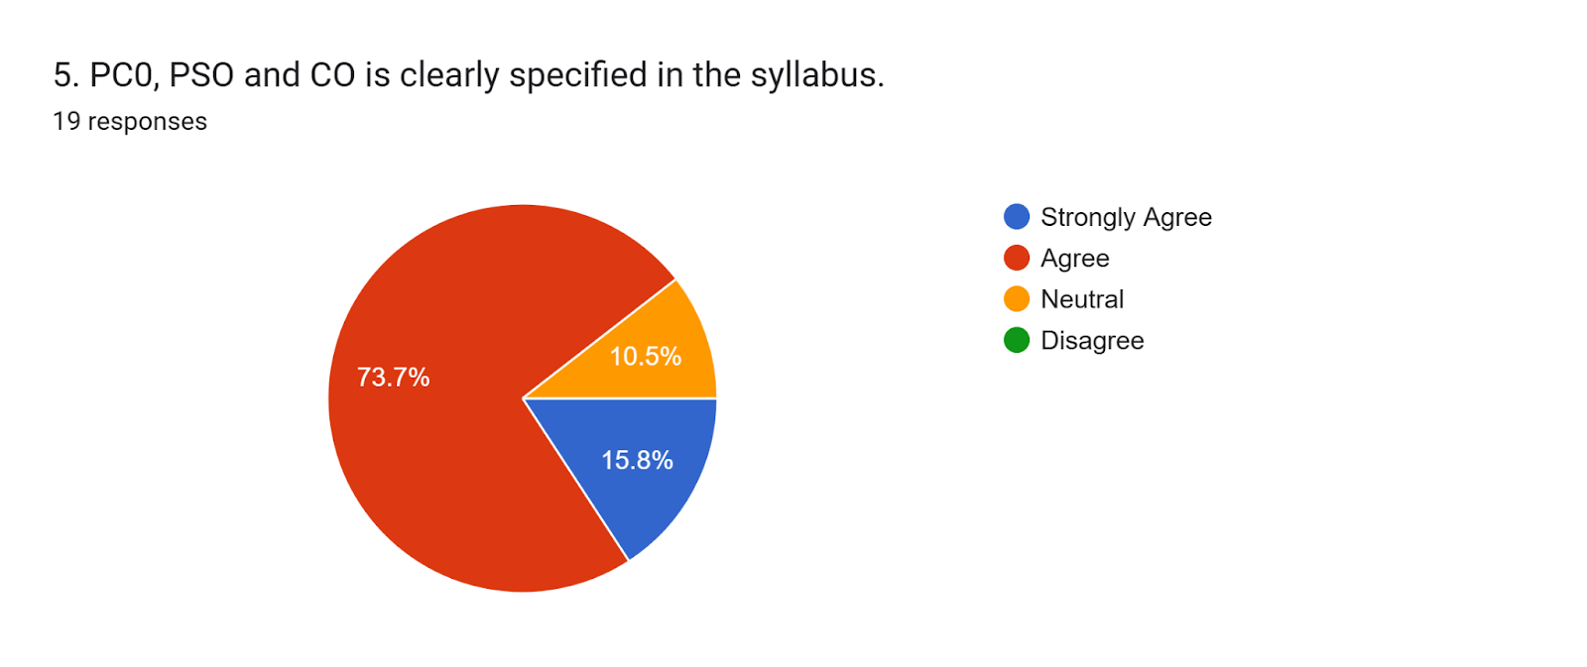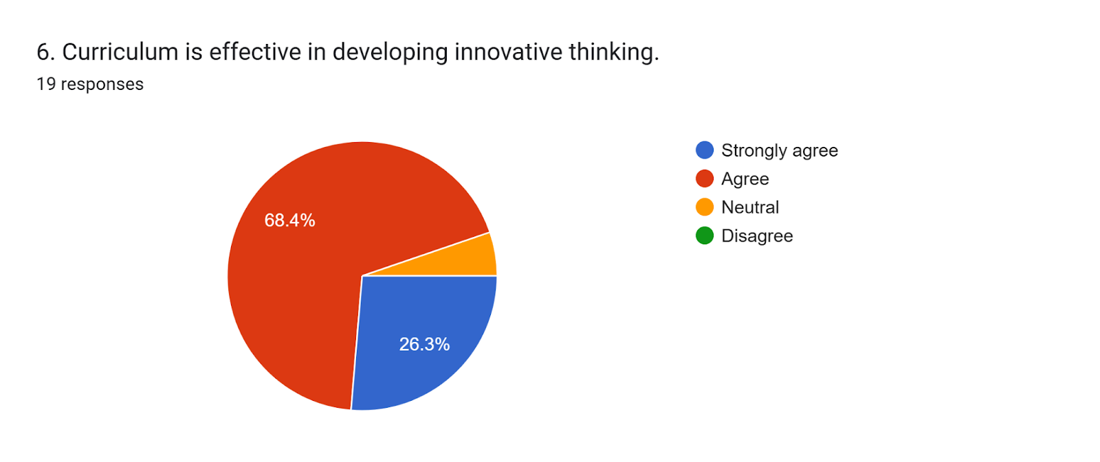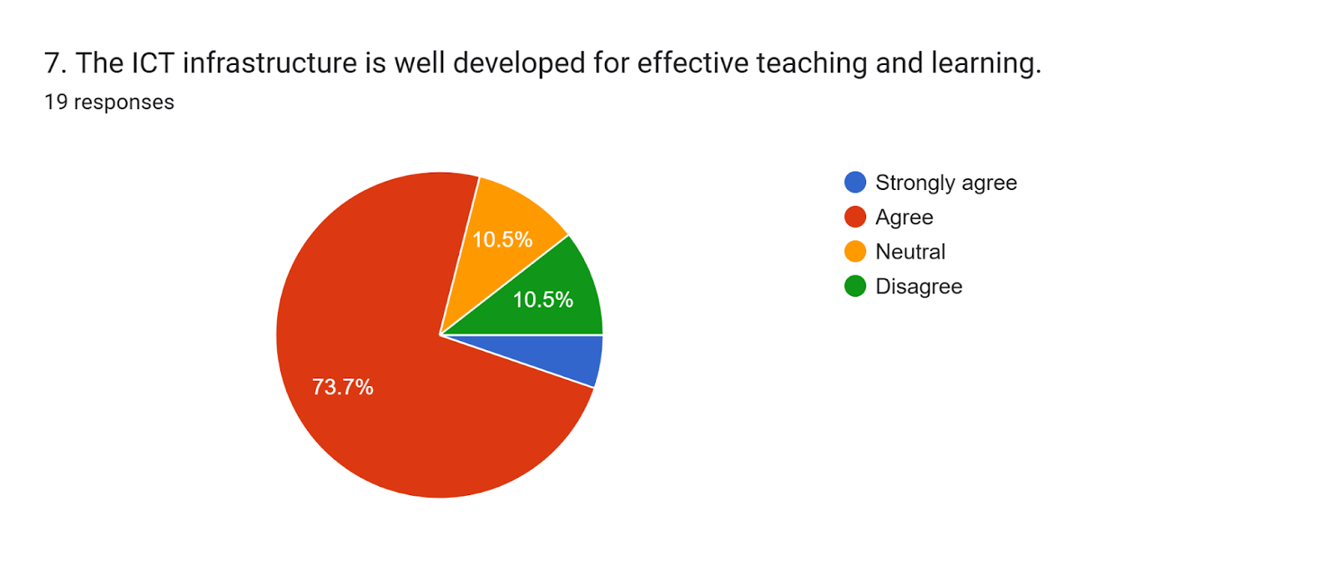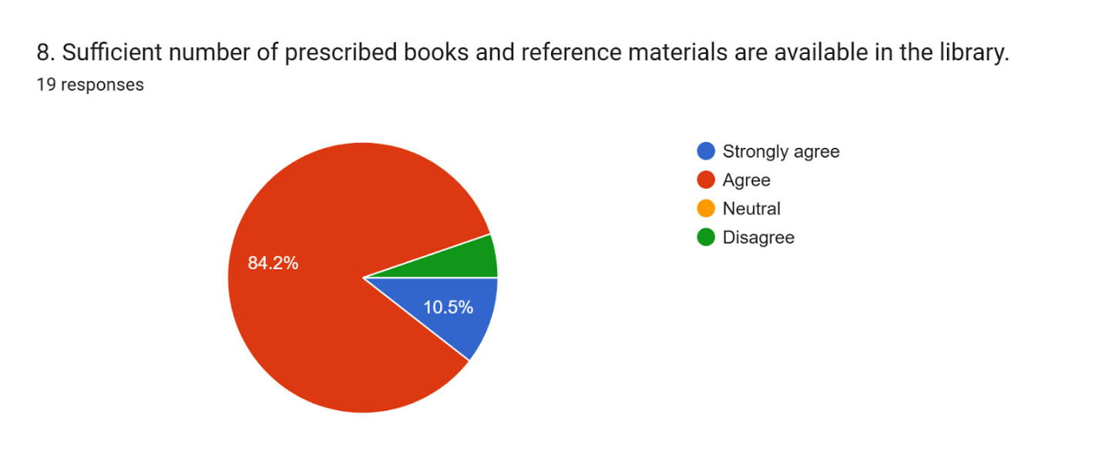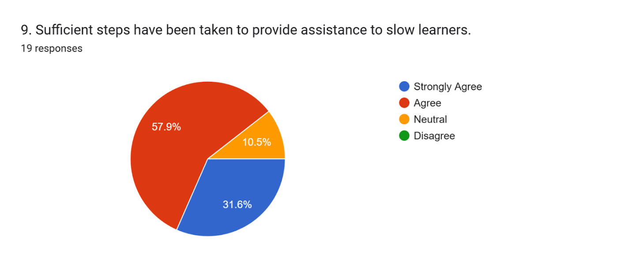
Suggestions for further improvement in the curriculum if any16 responses
Curriculum is effective and needful
No thanks
Curriculum is prescribed by the University. Some changes are needed to improve the curriculum.
Syllabus should be decrease
NA
Curriculum should me more practical
Mostly forward the infrastructure of the college to improve the students further study in higher education,
Curriculum should be more practical like developed countries.

Inclusion of emerging trends and technologies
No
Course of the sllyabus should be reduce for completed of the course mainor sllybus is essyer
Syllabus for major course should be minimized
Curriculum should be local need based .
Time management is very much adequate it is important for development.
Minor subjects should be easier than honours syllabus
Course of the syllabus should be reduced for completion of the course within the given period. Minor syllabus should be made flexible than Major

Feedback Analysis for Session 2023-24
Feedback From Students

https://docs.google.com/forms/d/e/1FAIpQLSeZPV3ERnxDjXE0da4nbNuVc700evHn4E3dVZXU21MMe5D0UQ/viewform

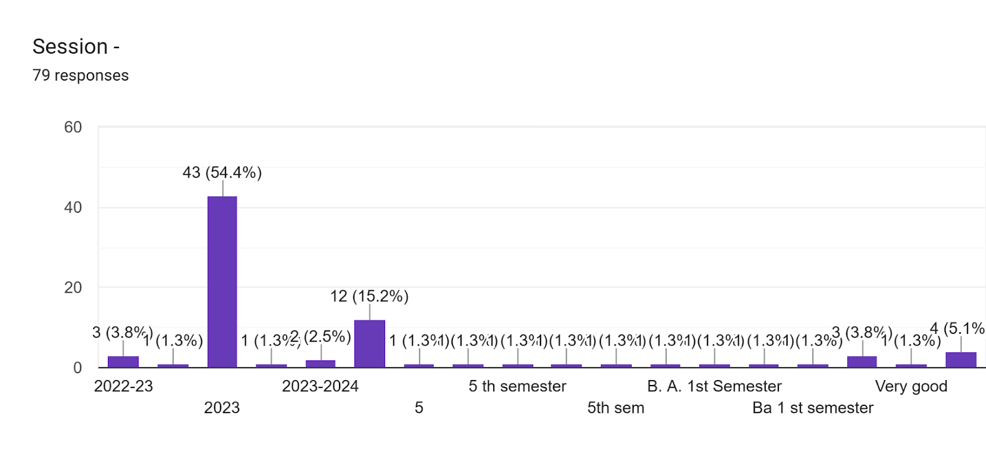

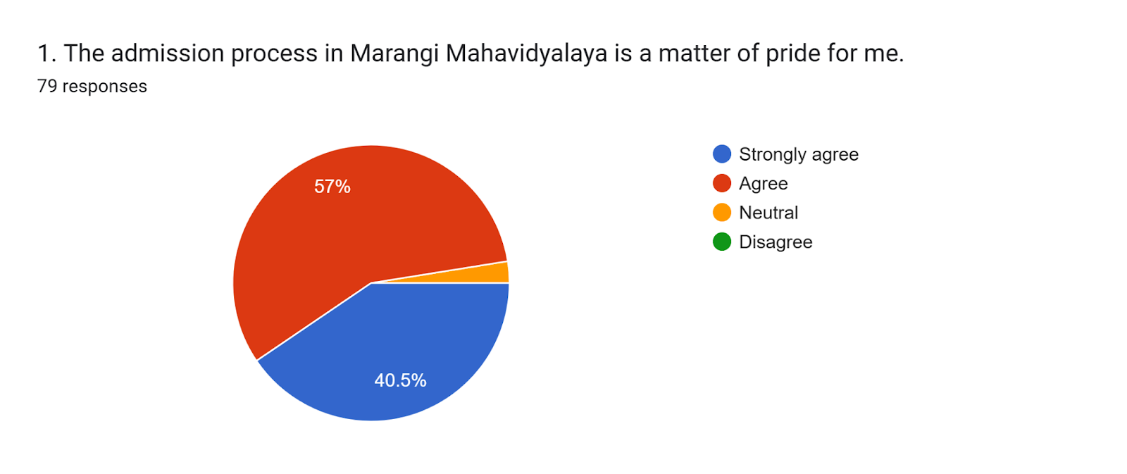

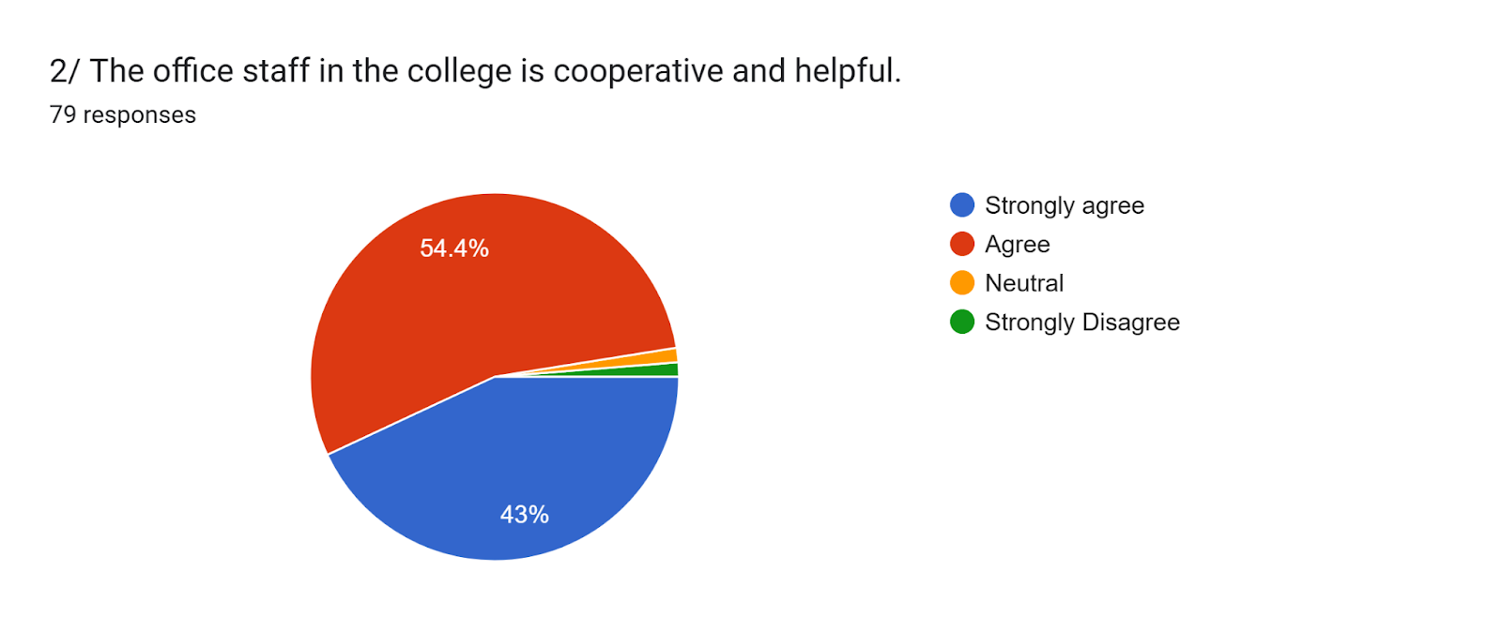

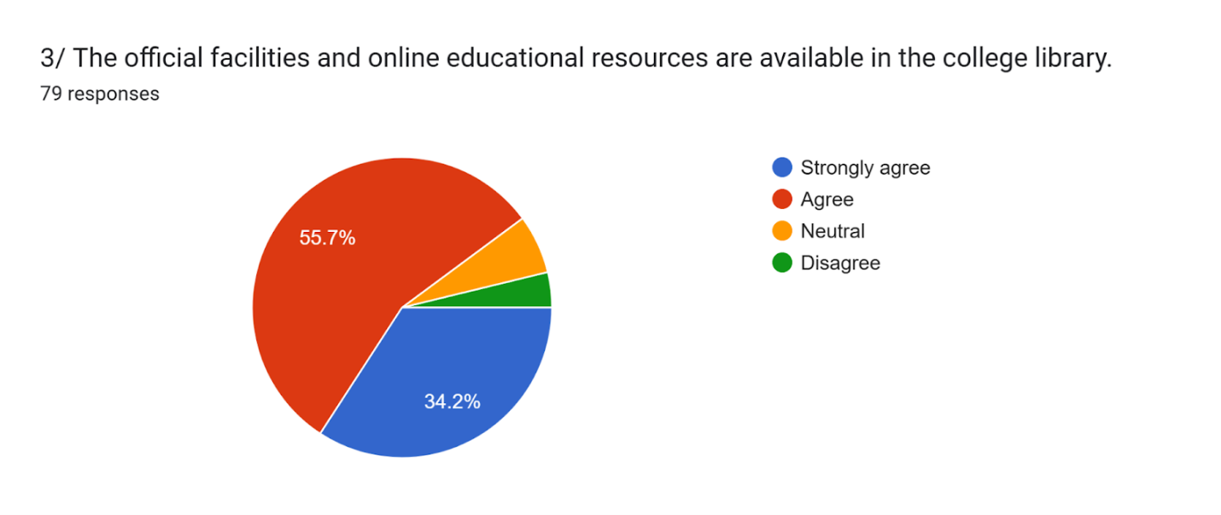

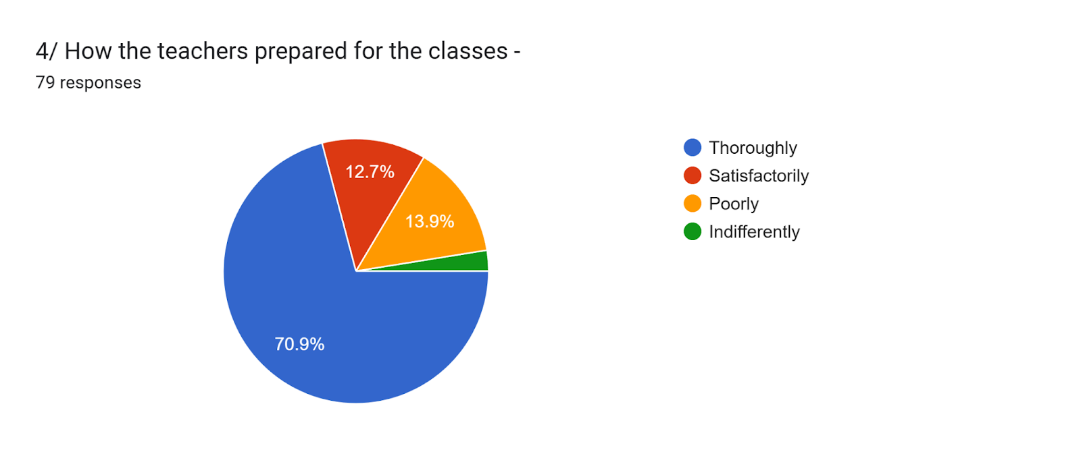

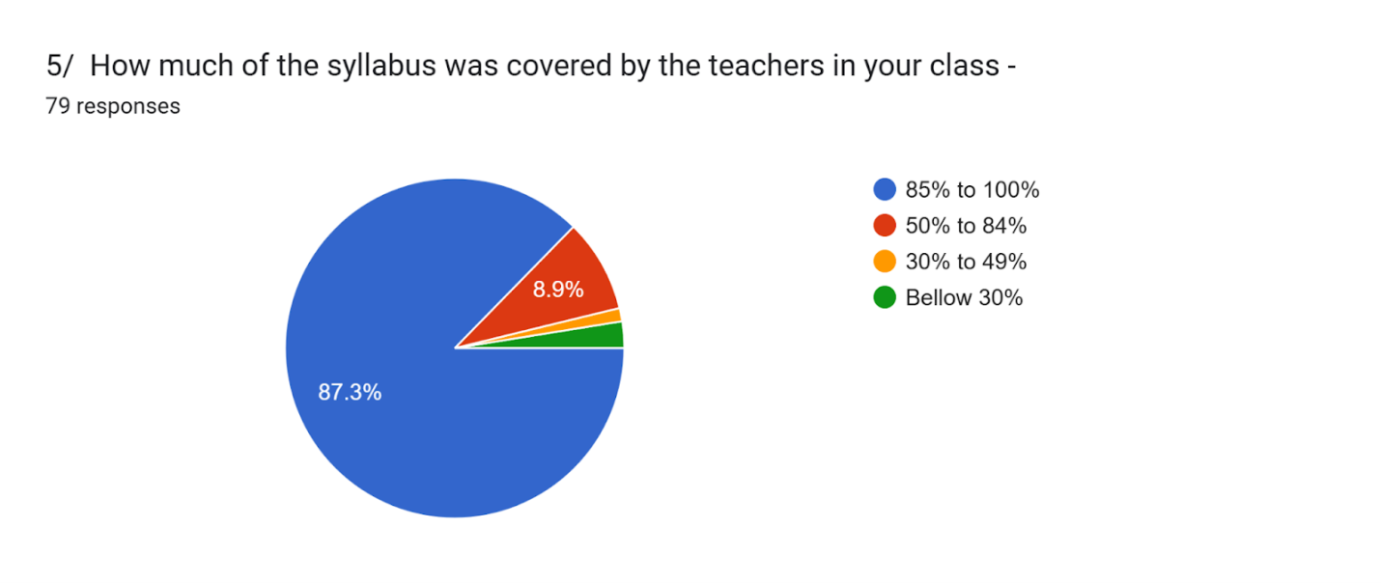

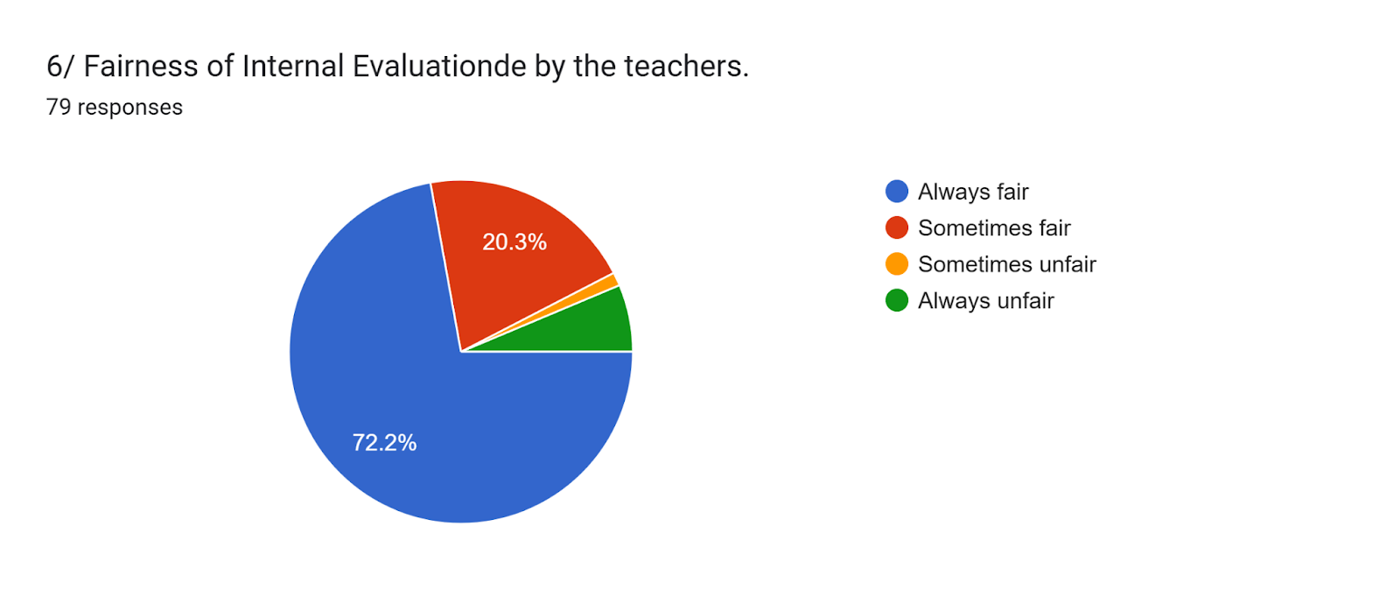

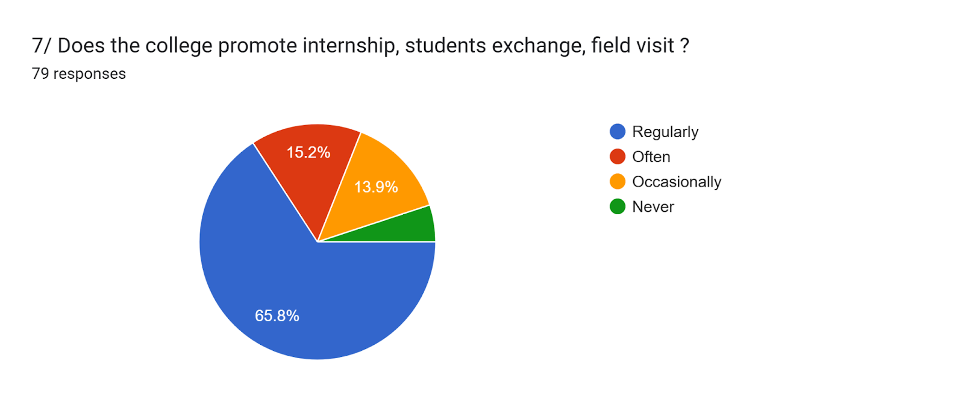

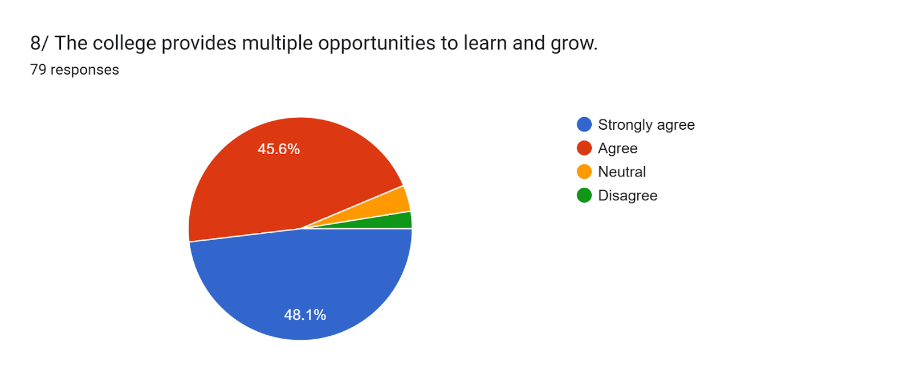

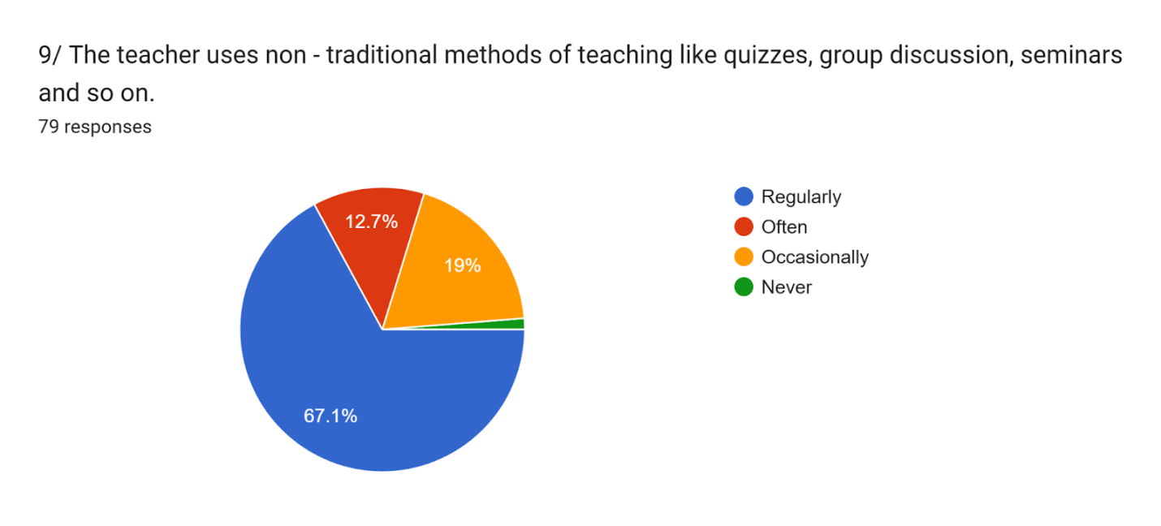

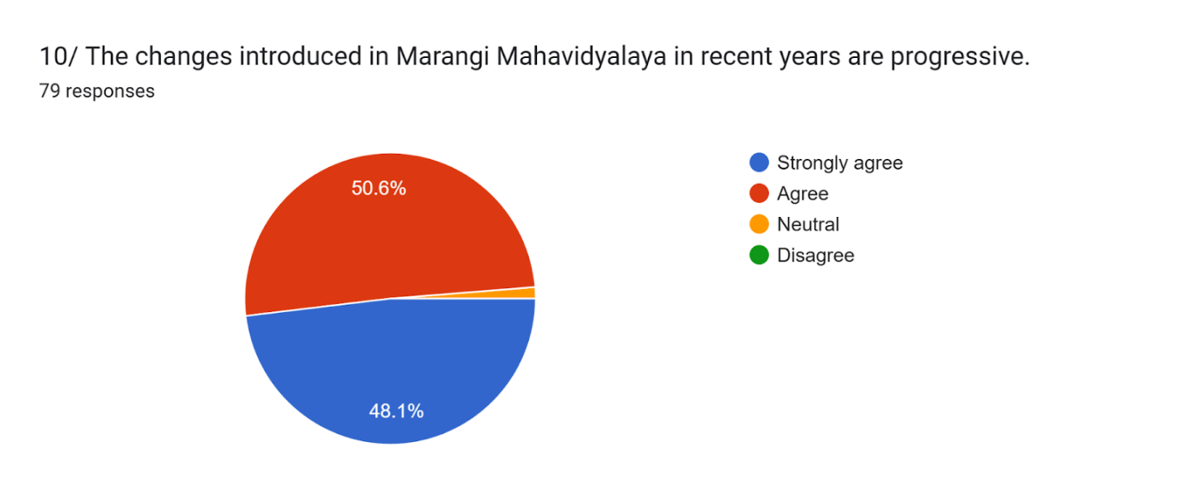

Feedback Analysis for Session 2023-24
Feedback From Students
https://docs.google.com/forms/d/e/1FAIpQLScY4t9NLA_vN4blY-3Zz8AGqkUouGvq4tc1RNL8uT_i5qJyzA/viewform?usp=header

